**SQL Tasks and queries:**

**Task 1:** **Listing the top 5 customers by total purchase amount.**

**Query:**

SELECT

c.CustomerId,

c.FirstName || ' ' || c.LastName AS CustomerName,

SUM(i.Total) AS TotalPurchase

FROM Customer c

JOIN Invoice i ON c.CustomerId = i.CustomerId

GROUP BY c.CustomerId

ORDER BY TotalPurchase DESC

LIMIT 5;

**Output:**

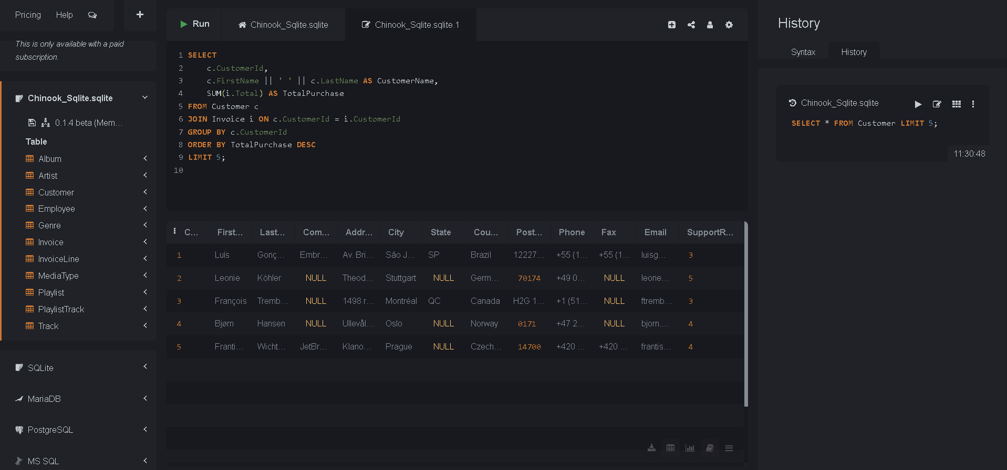

**Task 2: Finding the most popular genre in terms of total tracks sold.**

**Query:**

SELECT

g.Name AS GenreName,

COUNT(il.TrackId) AS TracksSold

FROM InvoiceLine il

JOIN Track t ON il.TrackId = t.TrackId

JOIN Genre g ON t.GenreId = g.GenreId

GROUP BY g.GenreId

ORDER BY TracksSold DESC

LIMIT 1;

**Output:**

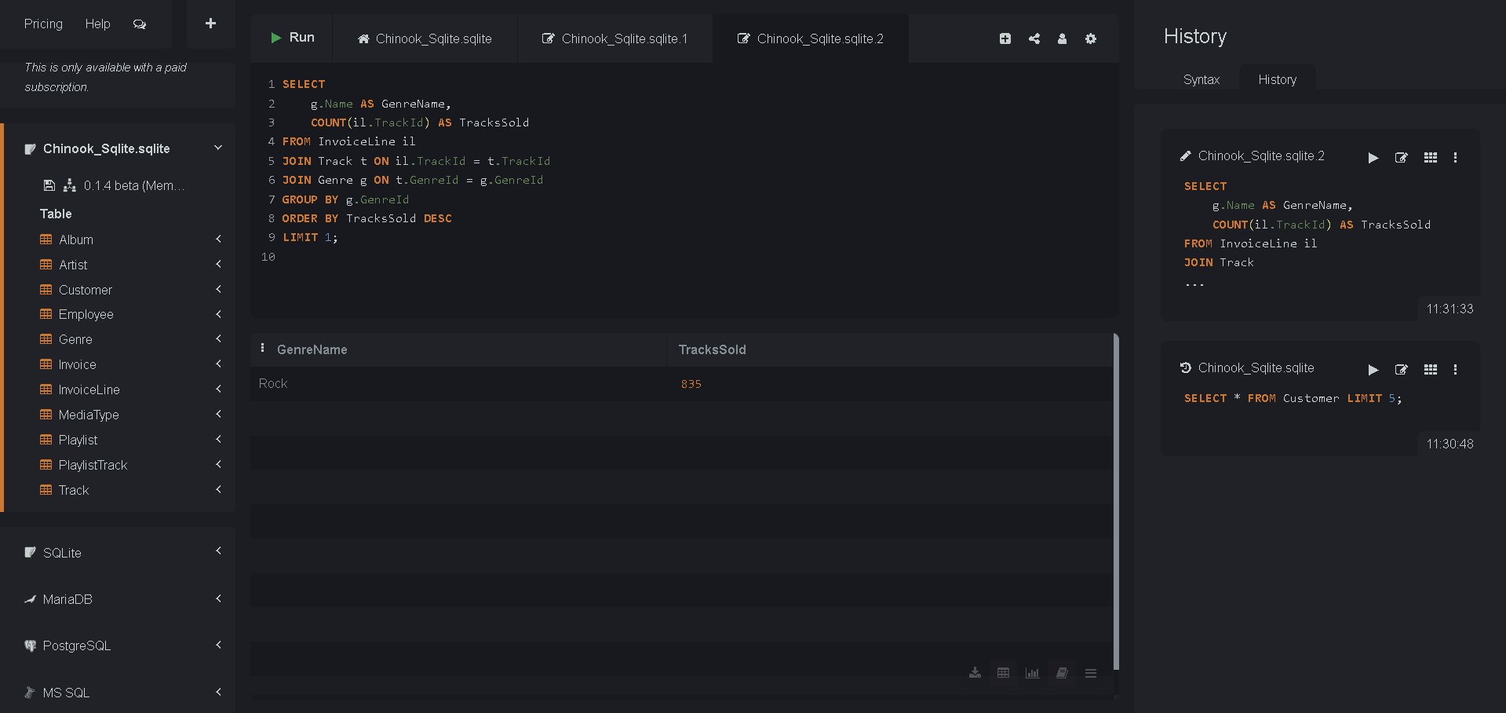

**Task 3: Retrieve all employees who are managers along with their subordinates.**

**Query:**

SELECT

m.EmployeeId AS ManagerId,

m.FirstName || ' ' || m.LastName AS ManagerName,

e.EmployeeId AS SubordinateId,

e.FirstName || ' ' || e.LastName AS SubordinateName

FROM Employee e

JOIN Employee m ON e.ReportsTo = m.EmployeeId;

**Output:**

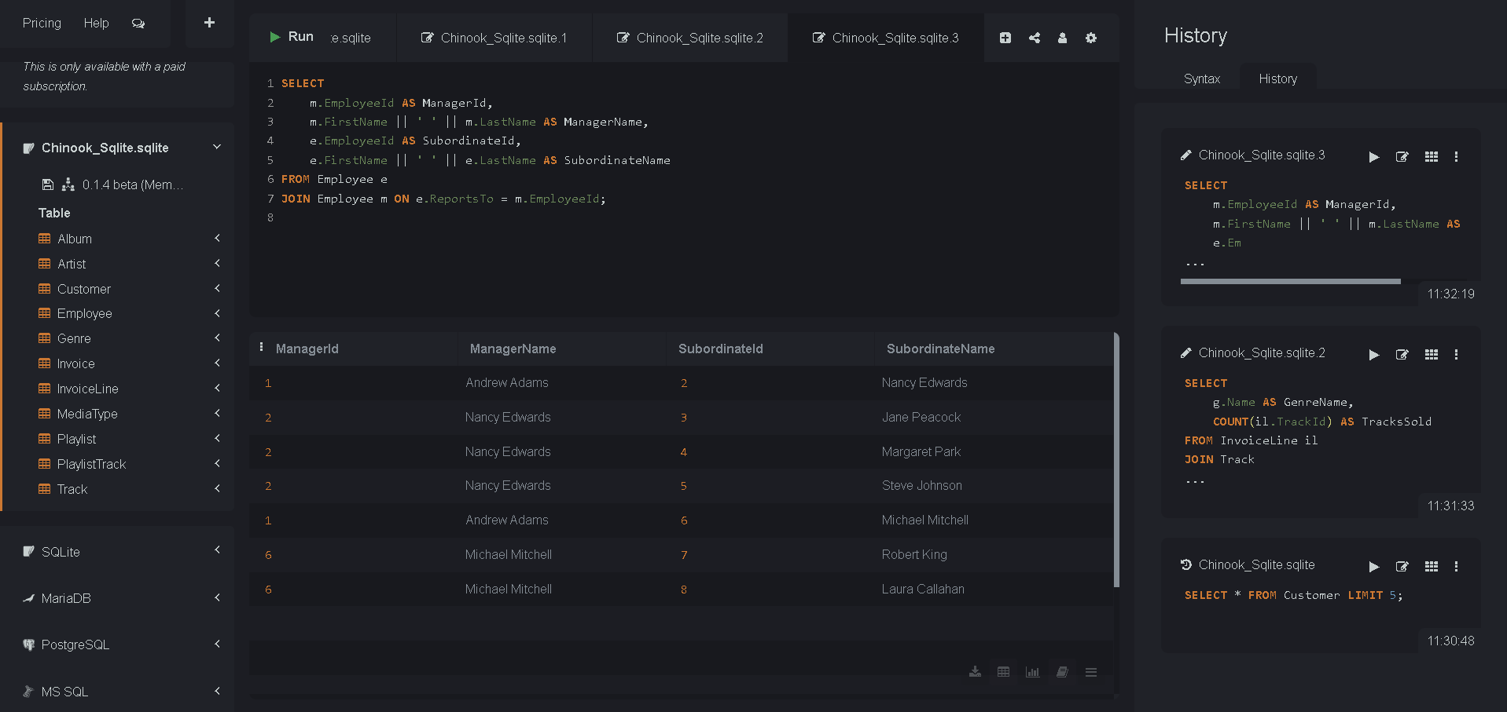

**Task 4: Finding most sold abum per each artist**

**Query:**

SELECT

ar.Name AS ArtistName,

al.Title AS AlbumTitle,

COUNT(il.InvoiceLineId) AS TracksSold

FROM Album al

JOIN Artist ar ON al.ArtistId = ar.ArtistId

JOIN Track t ON al.AlbumId = t.AlbumId

JOIN InvoiceLine il ON t.TrackId = il.TrackId

GROUP BY ar.ArtistId, al.AlbumId

HAVING TracksSold = (

SELECT MAX(track_count) FROM (

SELECT

COUNT(il2.InvoiceLineId) AS track_count

FROM Album al2

JOIN Track t2 ON al2.AlbumId = t2.AlbumId

JOIN InvoiceLine il2 ON t2.TrackId = il2.TrackId

WHERE al2.ArtistId = ar.ArtistId

GROUP BY al2.AlbumId

)

);

**Output:**

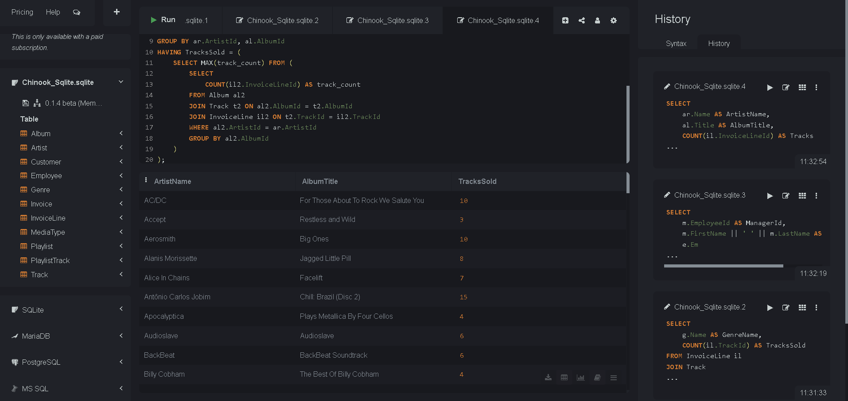

**Task 5: Getting monthly sales trend in 2013**

**Query:**

SELECT

strftime('%Y-%m', InvoiceDate) AS Month,

ROUND(SUM(Total), 2) AS MonthlySales

FROM Invoice

WHERE strftime('%Y', InvoiceDate) = '2013'

GROUP BY Month

ORDER BY Month;

**Output:**

